Benford’s Law and Regression Results Published in
Articles in New Zealand Economic Papers

David E. Giles

June 2026

ONLINE APPENDIX B: Distribution Plots and Confidence Interval Plots for All Random Sub-Samples

Figures 14(a), (b) in the text provide plots of the distributions for the 1st – digit and 2nd – digit empirical relative frequencies for the data relating to coefficients, standard errors and Student t-statistics for the sub-sample for the random samples with n = 1,000. To save space, plots for the other random samples were not included. They are provided in the plots in this document – that is, for n = 500, n = 1,000 and n = 2,000. Figures B.2 (a) & (b) correspond to Figures 14 (a) & (b) in the paper itself.

Also, Figures 15(a), (b) to 17(a), (b) in the text provide 95 % confidence intervals for the random sample with n = 1,000. Again, their counterparts for the other random sample sizes are omitted, but they are provided in this document. Figures C.4 (a), (b) to Figures C.6(a), (b) correspond to Figures 15 (a), (b) to 17(a), (b) in the paper itself.

n = 500
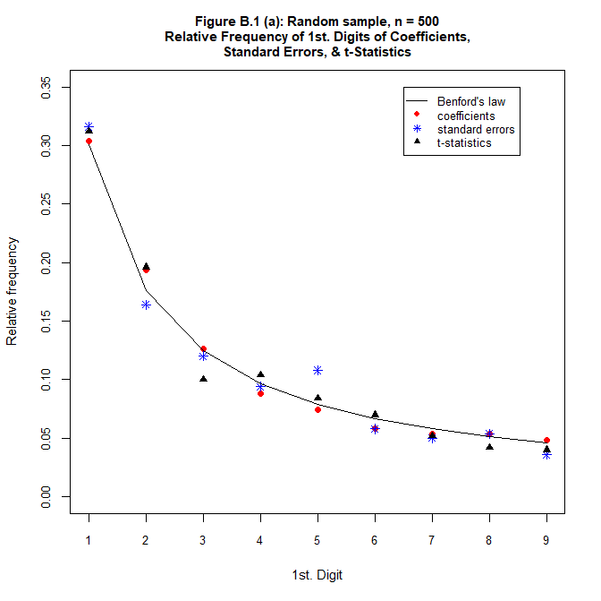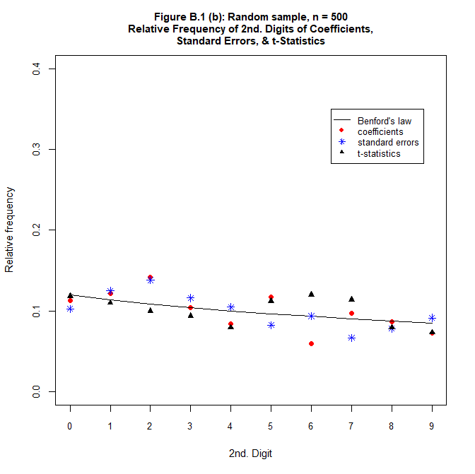
n = 1,000
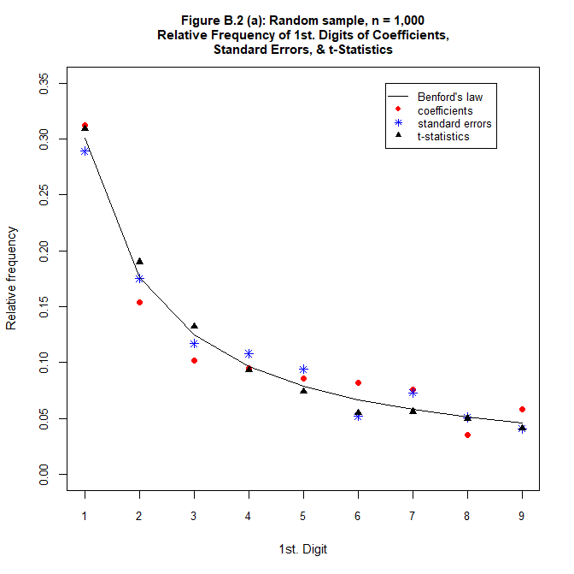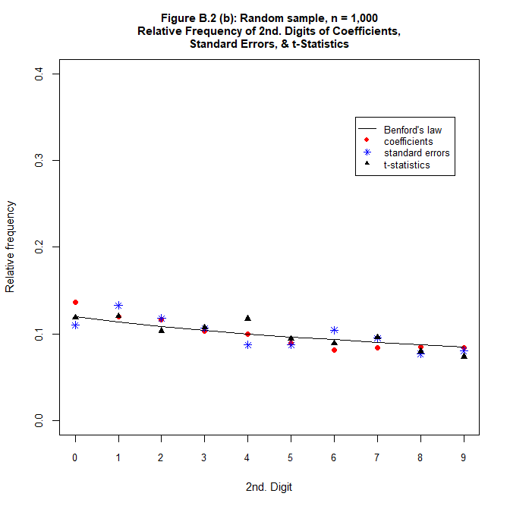
n = 2,000
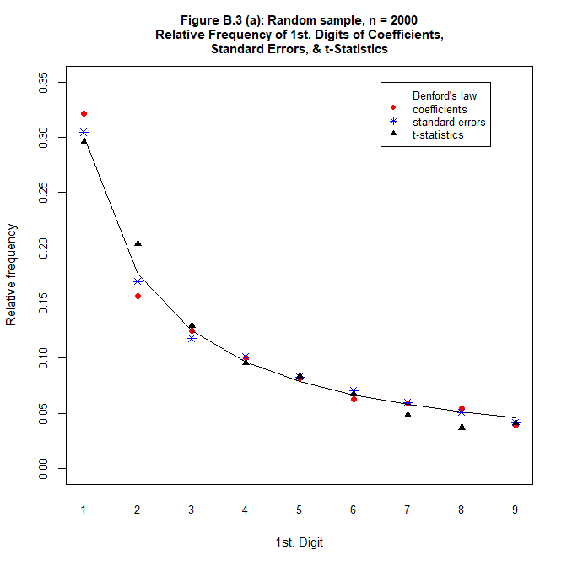
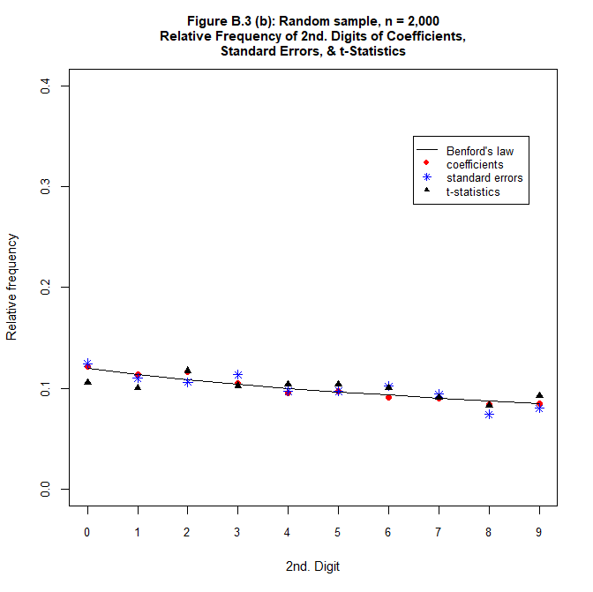
n = 500
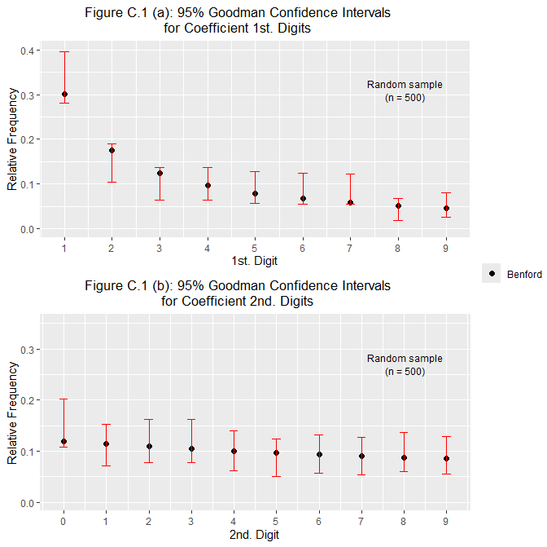
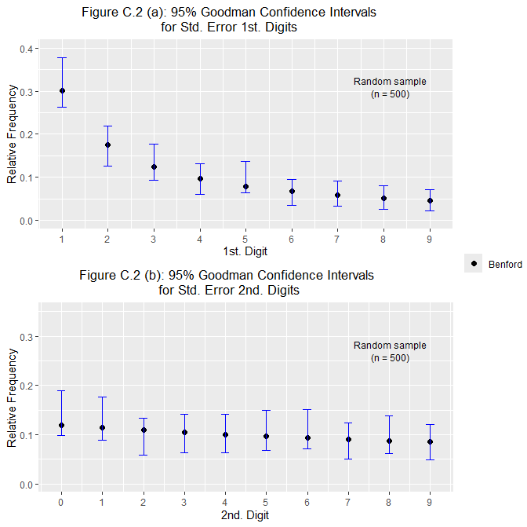
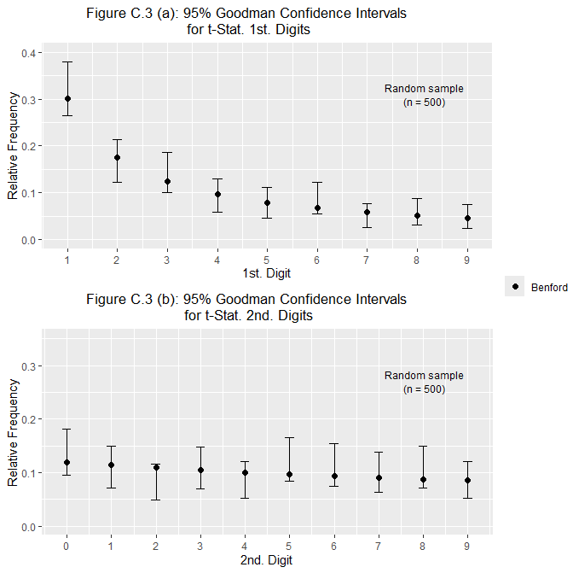

n = 1,000
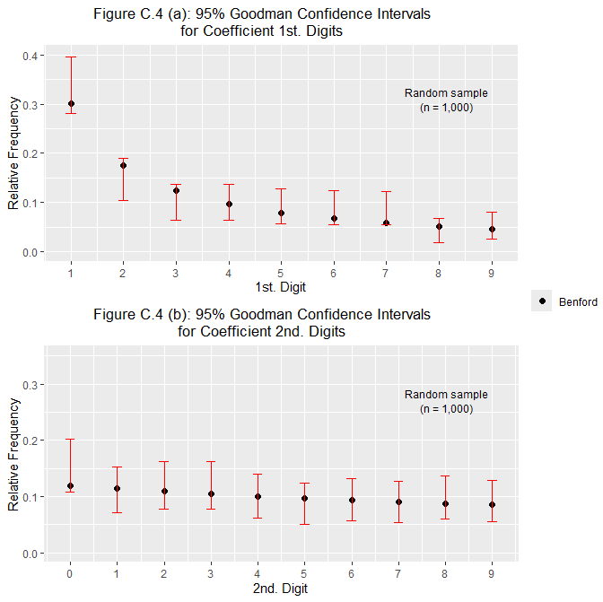
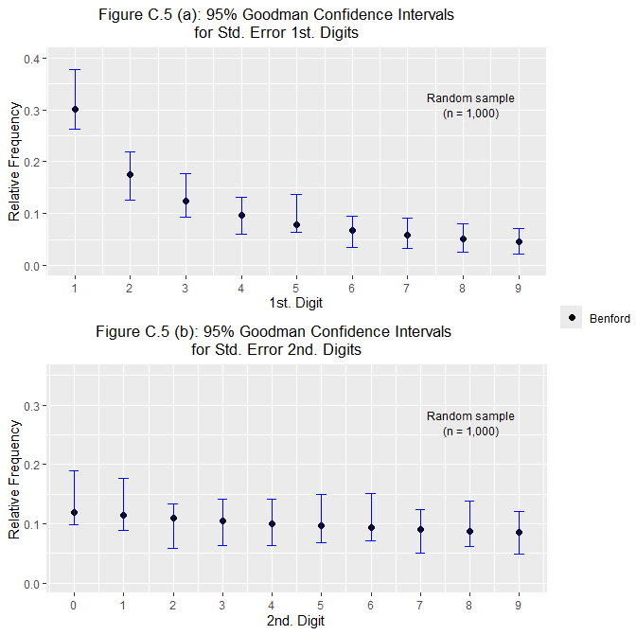
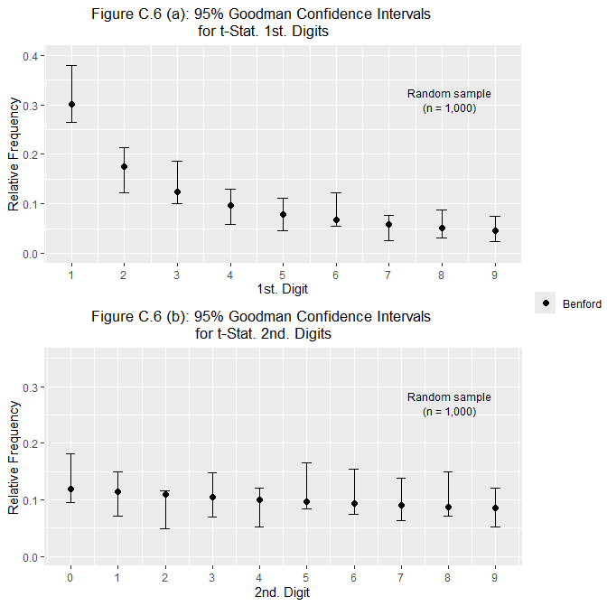

n = 2,000